
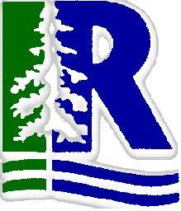
Iroquois Ridge High School
Department of Business

interoffice memorandum
to: ALL IRHS BUSINESS STUDENTS
from: ALL IRHS BUSINESS TEACHERS
subject: USE OF MEMOS FOR CLASS CORRESPONDENCE, ASSIGNMENTS, ETC.
date: July 30, 2026

IRHS Standards of Business

Any correspondence within your business classes (for absences or submitting assignments for example) should utilise forms and documents used in the business world. One such form is a memorandum (or memo).

What are Memorandums?

- Designed for sending written messages between employees within an organization
- Designed for short factual communication
- More informal than a business letter
- Does not need an inside address, salutation or closing
- Format to include the heading memorandum as well as four information lines: to, from, date, subject
- Sample format below (you may design your own)
- Note this handout is in a memo format

MEMORANDUM

To: Mr. Samsa, Leader

From: John Thomas, Student

Date: 2004 01 29

SUBJECT: ABSENCE FROM CLASS

This is to inform you that I will not be in your period 5 economics class on Friday, February 6 because I have a school hockey game. The team is being dismissed from school at the end of period 4.

I will certainly follow up on work completed and homework assigned.

