
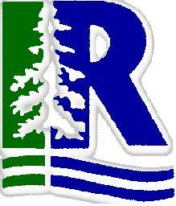
Iroquois Ridge High School
Department of Business

Team-Based Analysis

A great deal of the work you will do in post-secondary education, as well as in the world of work, will be based in teams. Group activities, therefore, are an essential exercise in developing your interpersonal and teamwork skills. The first thing you should note, is that there actually are ways to tackle an assignment as a team that are better than others. The follow is one example

- As a team, identify and clarify the task you’ve been given so that the whole group is ‘on the same page’. Articulate what it is that you wish to accomplish: set goals.

- As a team, “take stock”
  - Take an inventory of team member’s strengths
  - Take an inventory of the types of information, tools, resources, (etc.) that you have

- As a team, match tasks to appropriate individuals based on their strengths

- Break away and review the resources that you have as individual team members
  - Assess content
  - Identify the most significant information or resources
  - Perform an analysis on the resources (use frameworks of analysis – SWOT, Porter, Maslow, etc.)

- Come back with your results: all members should report their findings, discoveries, analysis, and insights back to the team as a whole

- As a team, decide on what to include, and what to discard (or at least not emphasize)

- As a team, organize the information into a logical, clear, and succinct (yet thorough) manner

When working as a team, it is important that groups elect a “facilitator/leader” who can keep the team on task. It is also vital that teams sit around a table facing each other so that all members are physically ‘part’ of the team and its discussions.

